Bhabha Atomic Research Centre, Mumbai
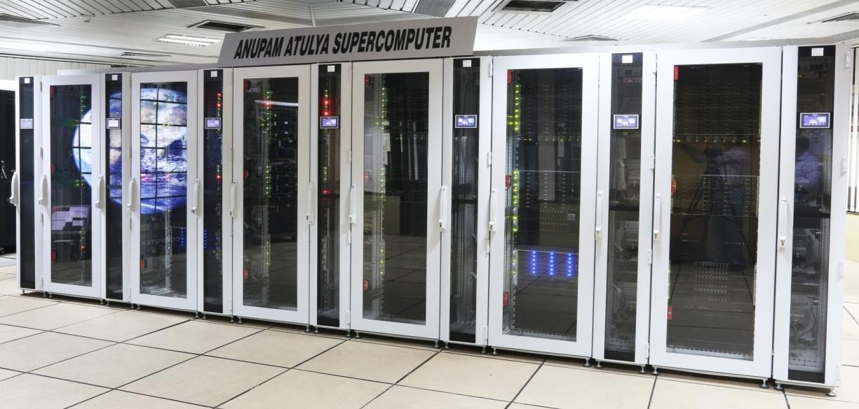

ANUPAM Atulya Supercomputer

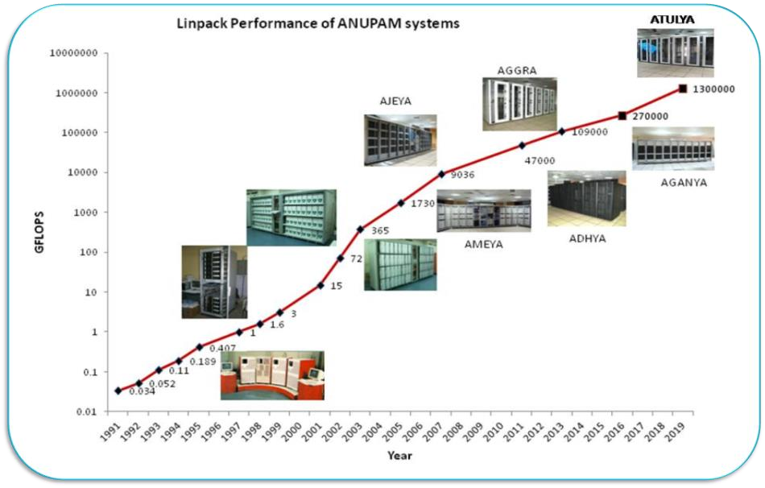

Computer Division, BARC has been developing supercomputers for past 28 years, to cater the computational requirements of scientists & engineers. Anupam Atulya is the latest supercomputer in ANUPAM series with sustained linpack performance of 1.35 PFLOPS . Its salient features are:

- 14720 Cores in 368 Compute nodes | - 128 V100 GPUs Accelerated Nodes
- 141 TB Memory | - 1500 Terabytes of Storage Space
- 100 Gbps Infiniband Interconnect | - 2.0 PFLOPS Peak Performance

IMSc Computer Network systems
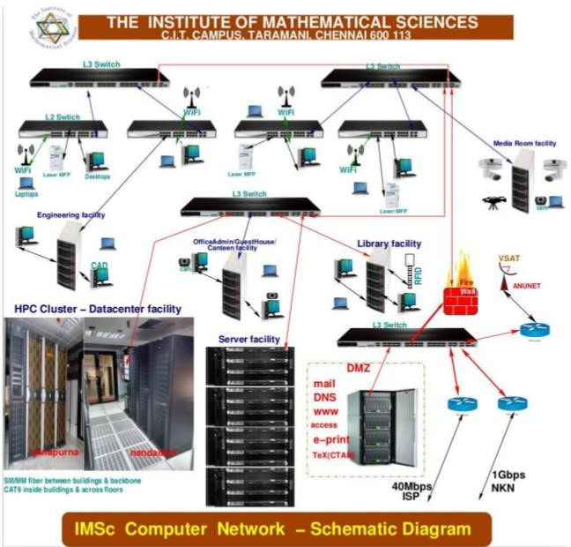

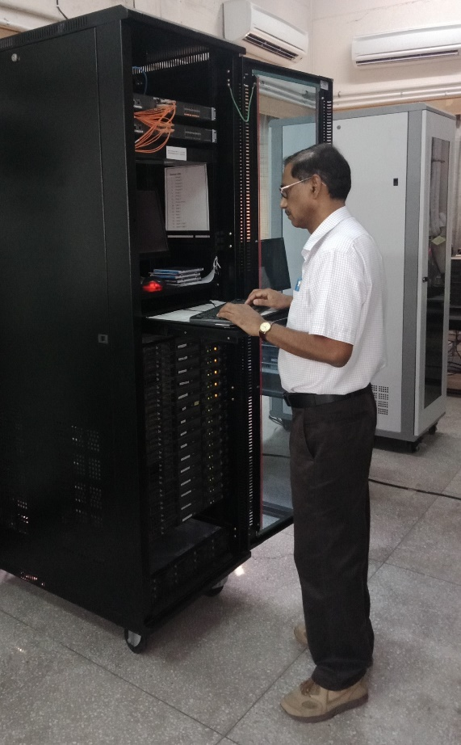
HRI
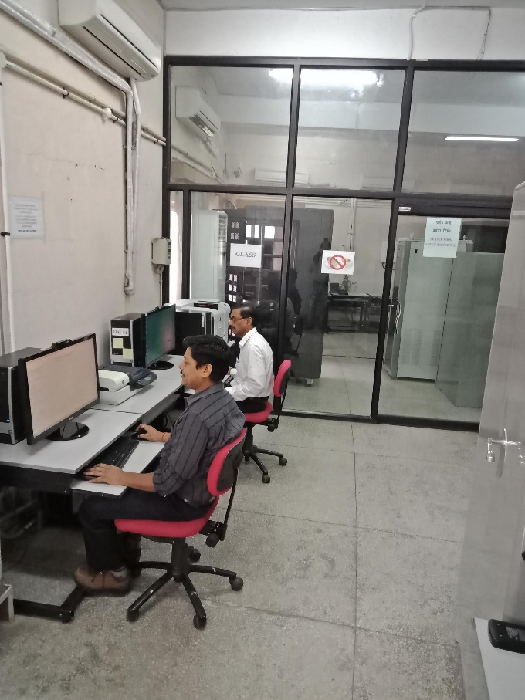
HRI Computing System

